Hi There.

Thanks for Downloading HubSpot’s Crisis Response Bank.
How to Use This Template
This document and attached templates are intended for your PR and/or crisis communications team. The first page should be dedicated to guiding principles – standards for the tone and approach your company should have when responding to crises – and how these messages will be communicated in these times.

Subsequent pages are dedicated to prompts for crisis communication. It should be emphasized that these statements are intended to inspire your own, authentic, unique, and situation-appropriate response. You are encouraged to change or alter any and all wording and phrasing so that it fits with your brand.

Manage your customer interactions with HubSpot Service Hub.  Handle tickets, conduct live chat, and create knowledge base articles. | 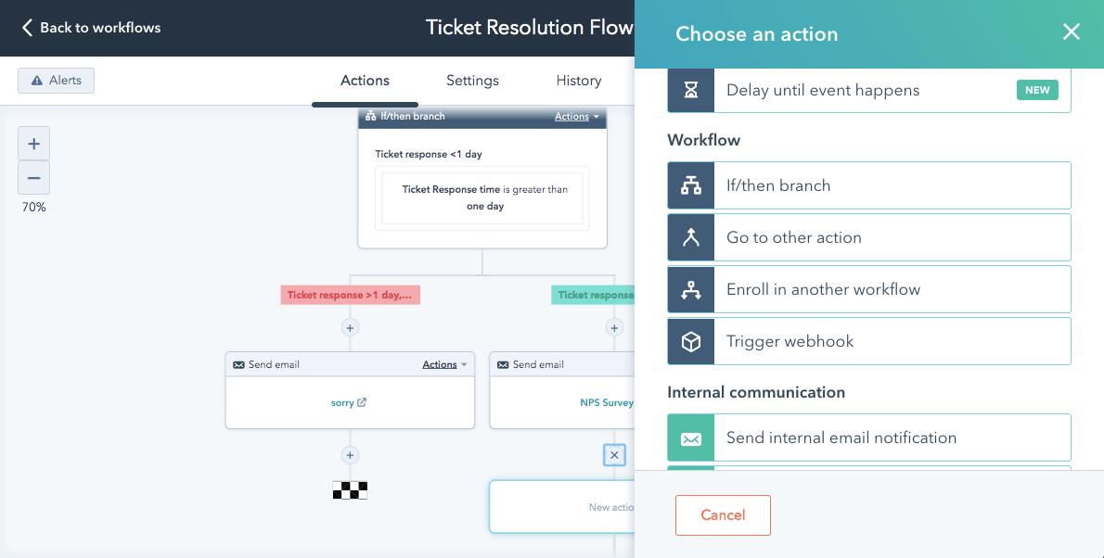
Get HubSpot’s Service Hub

Guiding Principle
Describe the purpose of this document.

Additionally, describe what best practices should be followed when issuing statements and/or responding to media inquiries during this time, including the tone, language, and approach to wording.

Communication Channels

List the ways you will communicate crisis updated both externally (website, customer emails, social media, etc.) and internally (employee email, meeting rooms, etc.).

External

- Channel
- Channel
- Channel

Internal

- Channel
- Channel
- Channel

Disclaimer: This response template is intended for informational purposes only. It is not a substitute for professional advice. You should work with your own crisis communication, public relations, media, security, legal, and other experts on any crisis communication plan, regardless of whether you choose to use this response template or not. HubSpot is not an expert in these matters, and is not responsible for your use or reliance on any information contained in this response template. If you do not agree to these terms, you may not use this response template.

General Mishap, Accident, or Mistake by the Company

We owe our customers an apology. On [date], [describe incident that occurred]. As a result, [impact on customers]. We’re sorry for what happened – we take full responsibility for our actions and the impact this had on our customers. After reviewing the situation, we found the cause to be [cause of mistake here]. We are committed to ensuring our customers, employees, and stakeholders don’t have to deal with this again by [preventative measures here]. [Account managers/customer service/the company] have been communicating with our customers during this time, and are still available to help address any continuing issues that resulted from this incident. Again, we apologize to our customers, and we pledge to be better.

Lawsuits

General
We cannot comment on ongoing litigation, but [company] is committed to [statement that does not divulge information or opinion about lawsuit].

Employee or Hiring Discrimination
We cannot comment on ongoing litigation, but we want to emphasize that [company] is an equal opportunity employer and that we [consider all applicants/evaluate all employees] without regards to race, color, religion, national origin, age, sex, marital status, ancestry, physical or mental disability, veteran status, gender identity, or sexual orientation.

Sexual Harassment
We cannot comment on ongoing litigation, but we wish to emphasize that [company] sees providing a safe and inclusive workplace for all employees as imperative. We thank the [people/person] who displayed the courage to speak out and will be working with [him/her/them] to offer support and provide assistance during this time.

Accusations

Employee or Hiring Discrimination
We take diversity and inclusion seriously at [company]. We are an equal opportunity employer and [consider all applicants/respect all employees] without regards to race, color, religion, national origin, age, sex, marital status, ancestry, physical or mental disability, veteran status, gender identity, or sexual orientation. Our goal is to ensure that we are providing a safe and inclusive workplace for all employees. As such, we are actively and seriously reviewing [this claim/these claims] to determine the appropriate next steps.

Sexual Harassment
At [company], we believe that all employees should treat each other with respect. We stand with any individual who has the courage to speak out when those values are not honored. Our goal is to create a safe and inclusive workplace for all. We are actively reviewing [this claim/these claims] to determine the appropriate next steps, and are offering our full support to the [person/people] who came forward.

Active Shooter / Violence on Site
There is [suspicion/confirmation] of an [active shooter/bomb/threat] onsite at [company]. Our priority is the safety of everyone onsite and in the surrounding area. We are communicating and working with authorities to contain and resolve the situation, and ask everyone to refrain from contacting or visiting our [address/specific] location until authorities confirm it is safe to do so.

Unexpected Loss of CEO/Executive (Death)
We are saddened to announce that [name] has passed away. Amidst this time of tragic loss, our focus right now is on supporting the people closest to [him/her], our employees, and all of those affected by [his/her] passing. [Insert name], who had the benefit of working closely with [name], will be serving as interim [Title of deceased].

Unexpected Loss of CEO/Executive (Unexpectedly Quits/Resigns)
[Name of employee] has resigned from [his/her] former position at [company] as [title], effective [date]. [name] will assume the position of [title] on an [interim/permanent] basis. We believe this transition will aid us in achieving our mission as a company. We wish nothing but the best for [resigned employee] and [his/her] successful and prosperous future, and we thank [him/her] for [his/her] [months/years/decades] of dedicated service to [company].

Unexpected Loss of CEO/Executive (Removed from Role)
[Company] can confirm [employee] is parting ways with the company, effective [date]. [Optional: If this termination is due to a public crisis, such as harassment or illegal activity, mention that his/her behavior was unacceptable at the company, and to protect the integrity of your company, he/she was removed from his/her position]. We have officially named [name] as [interim/permanent] [title]. We believe this transition will aid us in achieving our mission as a company. [Optional: If this termination is due to a public crisis, such as harassment or illegal activity, mention that the company is actively reviewing the situation and what steps will be taken to ensure this does not happen again].

Major Offensive Statement or Action by Employee

When There is Evidence (Video, Image, or Audio)
The viewpoints expressed by this employee do not represent [company’s] values at all, and we empathize with those hurt, upset, and disturbed by the employee’s [words/actions]. We emphatically denounce what [employee] has [said/done], and as a result, [his/her] employment has been [terminated/suspended/placed under review]. We are determined to provide a safe and inclusive work environment at [company] and are working with our [people operations/human resources/executive/legal] team(s) to determine the best course of action. Again, we wholeheartedly apologize to [person/people] affected.

When There is Only an Accusation
[Company] is committed to being a safe and inclusive workplace for all. We’re still assessing the situation and these accusations. We want to understand what happened, and our next step will be to work with our [people operations/human resources/executive/legal] team(s) to determine the best course of action. In the meantime, we would like to offer our sincerest apologies to all of those affected or upset by these accusations.

