Hi There.

Thanks for Downloading this Resource.

How to Use This Template
This template should be used once you’ve emerged from your corporate crisis. In the table, there are section prompts for you to explain how well you believe the team did in responding to the crisis and why.
Once complete, have the crisis response team speak about why certain marks were achieved and what can be done to improve them in future instances.

Manage your customer interactions with HubSpot Service Hub.  Handle tickets, conduct live chat, and create knowledge base articles. | 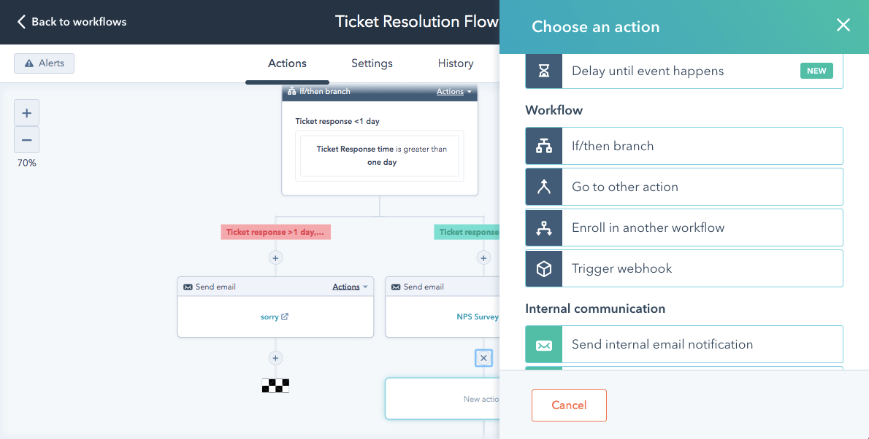
Get HubSpot’s Service Hub

Post-Crisis Self-Rating Template

Have all members of your crisis communication and management team fill out this assessment. Rate your perceived performance for first response and follow up from 1-5, giving reasons as to why you ranked your performance this way. If you feel there are any learnings that can be applied for the next situation, document them in the next steps column.

 | First Response | Follow Up | Next Steps
Prompt
Did we respond quickly?
Informative
Did we address the basic information needs for internal and/or external stakeholders?
Sincere
Did we respond with humanity and care, showing empathy for people impacted by the crisis?
Honest
When known, did we clearly explain what happened, what is happening, and what will happen next?
Humble
If applicable, did we as a company own our mistake?

